# Permanente Evaluatie 3_lineaire algebra

## Opgave 1

a)

0.26

0.61

0.58

|  |  |  |  |
| --- | --- | --- | --- |
| I | II | III | IV |

0.7349

0.7349

0.7349

B)

$$\left[\begin{matrix}0 & 0.7349 & 0.7349 & 0.7349 \\ 0.58 & 0 & 0 & 0 \\ 0 & 0.61 & 0 & 0 \\ 0 & 0 & 0.26 & 0\end{matrix}\right]$$

C) De klasse wordt steeds kleiner.

D)

|  |  |  |  |  |  |  |  |  |  |  |  |
| --- | --- | --- | --- | --- | --- | --- | --- | --- | --- | --- | --- |
| Jaar | 2010 | 2012 | 2014 | 2016 | 2018 | 2020 | 2022 | 2024 | 2026 | 2028 | 2030 |
| 0-3 | 166 |  | 366 |  | 177 |  | 219 |  | 181 |  | 164 |
| 4-7 | 166 |  | 96 |  | 212 |  | 103 |  | 127 |  | 105 |
| 8-11 | 166 |  | 101 |  | 59 |  | 129 |  | 63 |  | 77 |
| 12-15 | 166 |  | 43 |  | 26 |  | 15 |  | 34 |  | 16 |

E) we kunnen hieruit besluiten dat de diersoort met uitsterven bedreigd is.

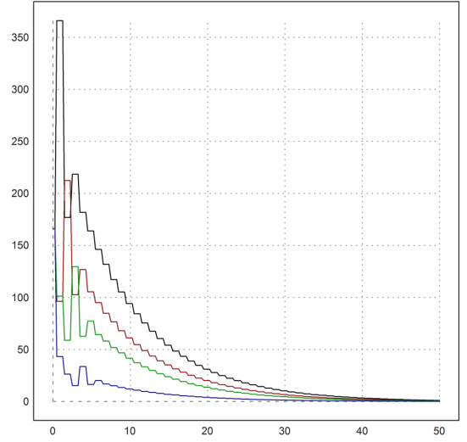

## Opgave 2

1.

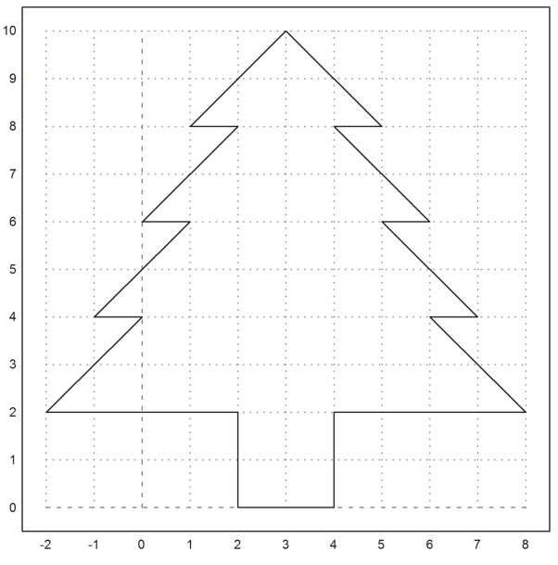

2. A)

B) Ja,

C)

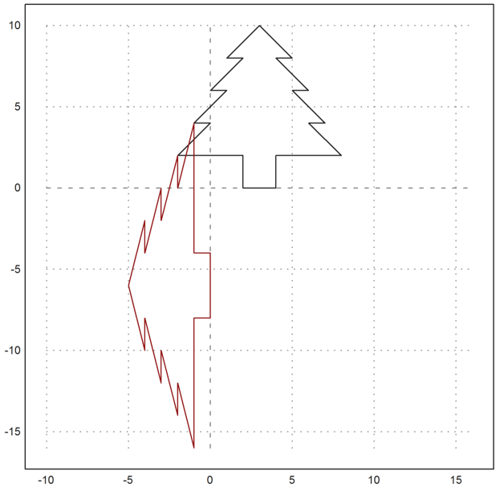

3. A)

B) neen

C)